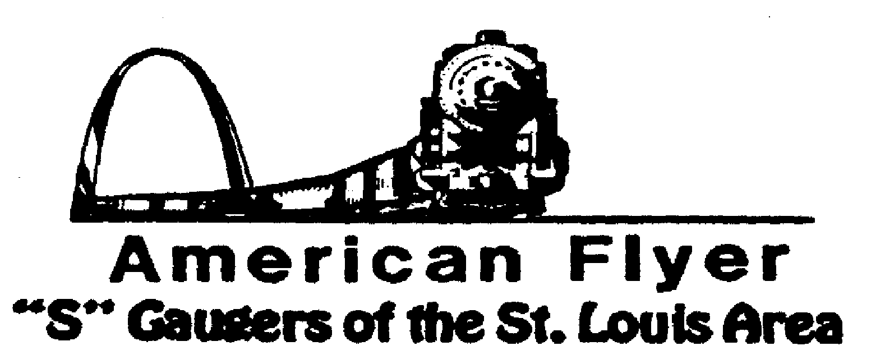

Website: www.trainweb.org/afsgsla/ E-Mail: afsgsla65@gmail.com
______________________________________________________
AFSGSLA LETTER
April 2022

AFSGSLA Club Events and Related Activities:

As with the last several newsletters, we are combining the planned club events and the other related activities. Although we will not necessarily participate in some of the following events as a club, they are included in this somewhat comprehensive listing for your information. We suggest you keep this newsletter for your future reference and attend our club meetings for full details.

NOTE: This newsletter corrects some errors and omissions caused by the rush to get it out with Moe’s funeral details.

Saturday, April 9, 2022: The Sons of the American Legion Spring Train Show, 10:00 am - 3:00 pm American Legion Post #485, 200 South 5th Street, Dupo IL 62239
Friday, April 22, 2022: Club meeting hosted by Joel Weber. Joel’s address and contact information is 1124 Pinrun Drive, Ballwin, MO 63011. His phone number is 630-977-9323 and email is weber1b14@gmail.com. He said parking in the driveway is fine. He also encourages carpooling, just to limit the number of cars on the street. 7pm is the normal start time for the meeting.
Saturday, April 30, 2022: 6th Anniversary Railroad Swap Meet, sponsored by the Iron Spike Model Train Museum, 10 am - 3 pm, Washington City Auditorium, 211 High Street, Washington MO 63090, Admission $8, includes same day admittance to Iron Spike Museum
Saturday, May 14, 2022: After the storm train show at Meramec Elks Hall, 10 a.m. to 2 p.m. It is located at 1515 Miller Road in Imperial, MO 63052. $3.00 at the door.
Saturday May 14, 2022: Club meeting hosted by Bob Muehling has invited us to hold our April club meeting at his home (1208 Twinleaf Circle in St. Peters, MO 63376, and his Telephone is 636/ 978-0870). We will start gathering at about noon. NOTE: Bob plans on serving lunch. Bob would probably appreciate it if you rsvp so he knows how much to get. Also, if you are going to the train show in the morning, please plan on leaving early enough to make it to Bob’s for lunch. Bob and Dee Muehling have been most generous in hosting our club meetings in the past and we are always impressed with the improvements made on their layout and the trains around the ceiling.
August 12, 13 &14, 2022: NMRA convention in Collinsville, Illinois. There is the possibility to display our sectional layout for the 3-day show, this would be for exposure only, there would be no compensation. A decision has not yet been made, but we are leaning to declining.
Friday, September 9, 2022: Cliff Saxton once again invited us for our September club meeting at its usual time.
September 10, 2022: IT’S BACK!! Boeing Railroad Club train show at the Greensfelder in Queeny Park.
Saturday, September 24, 2022: Pacific Eagles Train Show. 10:00 a.m. to 3:00 p.m. 707 Wet Congress Street, Pacific, Missouri. Admission is $3.00.
Saturday and Sunday, October 8 & 9, 2022: Mississippi Valley N Scalers (MVNS) show at the Kirkwood Community Center, Kirkwood MO. It is anticipated that we will be displaying our sectional layout this year.
Note: As of now, there is nothing on the schedule for GATS showing a Belleville or Collinsville show.

What’s been happening?

Saturday and Sunday, January 29-30, 2022: Great Train Show, St. Charles Convention center. We displayed our sectional layout. Barry Dolan coordinated.
February 2022: We displayed our sectional layout at the National Museum of Transport for the whole month. The Museum did compensate the club for this month long display.

This and That

St. Louis Lionel Railroad Club – The club has a new home! The club voted to accept an offer from St. Matthias parish for the rental of two former classrooms. In addition to the two classrooms, the club will have access to a large meeting room with kitchen facilities. The set-up will be very similar to what the club had when it was at the old Windsor school. The parish holds fish fries, barbeques and other events that they can hopefully piggyback onto to display the future layouts. St. Matthias is at 796 Buckley Road (Buckley Road is the stoplight by Dierbergs across Lemay Ferry from Reinhold Electric), approximately three miles from the former location, but in a much better neighborhood.
2024 Fall S Fest Report – The steering committee met to discuss the feasibility of the AFSGSLA hosting the Fall S Fest at its next scheduled date, sometime in the fall of 2024. No decision has been made, or will be made, until a thorough analysis has been made, especially the cost aspect, and how much we could potentially “be on the hook” for. With the exception of the 2021 SFEST held last year, all previous SFEST have been profitable. The problem with last year centered around having it a year later and not passing on the 2021 cost increases. If we decide to host an SFEST, we will need ideas for a theme, cars, etc. Do start thinking.

2023 Fall S Fest – At the 2021 S Fest, Chicagoland said they planned to host the 2023 S FEST. Nor date or location has been received yet.

2022 Fall S Fest – As of now, there is no 2022 S Fest scheduled. Unfortunately, State Line had to decline sponsoring it. The 2023 S Fest in Chicago is currently a go. As of this writing, it is assumed that there will be no 2022 S Fest.

Midwest Money Layout Open House - Sponsored by the Midwest Money Company, on the First Sunday of every month from 11:00 A.M.to 4: P.M. They are located at 5901 Hampton, St. Louis MO just across Holly Hills Street. The layout is rather large, fully developed scenery 3 rail O-Scale layout. This rather large layout may be one of only a very few which can be claimed to be 100% complete. This location is in South St. Louis City, roughly halfway between Chippewa and Gravois

IN MEMORIUM

Sorry to get this out late but wanted to let our club members know that Russell Bill passed away on Tuesday, March 15th. There was no formal memorial service but I understand that there will be some kind of special service sometime in April. Russell’s obituary can be found here: https://www.pitchfordfuneralhome.com/obituaries/Russell-Warn-Russ-Bill?obId=24296352#/celebrationWall

Special notice from David Stevens: Dave has had it easy recently, but as you can see, we are hoping to get back to in person club meetings now in 2022. We have had a number of our faithful club members who have volunteered to host future meetings. Although our David Stevens is especially pleased with the excellent response to his recent requests, he tells us that we still need club members to volunteer to host club meetings in the future. He states that if you have not hosted a meeting recently---or ever---please carefully consider doing so. It is a great way to “pay your dues” and it really is not much trouble to host a club meeting (the club pays our host a modest fee to offset expenses for refreshments). We have often said (and our hosts have agreed) that there is no surer way of getting your train room shaped up then hosting a club meeting. David Stevens will help you with the details, if you just contact him at Telephone: 314/ 921-1127 or stevens8128@sbcglobal.net.

Notes from your Co-Coordinators!
We are all deeply saddened by Moe Berk’s passing. Please continue to keep Rita, Moe’s daughters and their entire family in your prayers and thoughts. There has been some discussion of the Club’s best way to memorialize Moe, since he was the driving force of this Club for so long. One idea that we have thought about is a memorial brick to be placed at the Museum of Transportation in Moe’s honor. We will further discuss this at Joel’s meeting and hope to take action very soon.
TOM SCHNUR
AFSGSLA Co-Coordinator
afsgsla65@gmail.com

RICK ARCHESKI
AFSGSLA Co-Coordinator
rcheski@charter.net

That’s it for now, more later:
GARY MUELLER
AFSGSLA Newsletter Editor
gmatmueller@aol.com

-And remember, “It’s just for the fun of it!”

